Database Name: Admission.accdb

**List of Attributes for the database**

Class Div RollNo SAP# Salutation StudentFName StudentLName FatherName MotherName Gender DOB Nationality AadharCardNo Address City State PinCode StudentMobileNo GuardianMobileNo GuardianEmail ParentEmai Session UniversityName YearofPassing SeatNo GPA Subject# SubjectName

**ENTITY:** STUDENT, FAMILYINFO, EDUCATIONINFO, COLLEGE, EXTRACURRICULAR, MAJOR

**Attribute:** *SAPID, *FamilyID, *EduID , Salutation, FatherName, Qualification, StudentFName, MotherName, SchoolName, StudentLName, FatherMobileNo, SeatNo, Gender, MotherMobileNo, YearOfPassing, DOB, FatherEmail, GPA, MotherEmail, Nationality, FatherOccupation, MotherOccupation, AadharCardNo, Address, City, State, PinCode, StudentMobileNo, *RollNo, *MajorID, *ClubID, Class, MajorName, ClubName, Div

**STUDENT FAMILYINFO EDUCATIONINFO**

*RollNo *FamilyID *EduID

Salutation FatherName Qualification

StudentFName MotherName SchoolName

StudentLName FatherMobileNo SeatNo

Gender MotherMobileNo YearOfPassing

DOB FatherEmail GPA

Nationality MotherEmail

AadharCardNo FatherOccupation **MAJOR**

Address MotherOccupation *MajorID

City MajorName

State **COLLEGE**

PinCode *SAPID **EXTRACURRICULAR**

StudentMobileNo Class *ClubID

Div ClubName

**CREATING A CONCEPTUAL ERD**

**STUDENT**

*RollNo

Salutation

StudentFName

StudentLName

Gender

DOB

Nationality

AadharCardNo

Address

City

State

PinCode

StudentMobileNo

SAPID

FamilyID

MajorID

ClubID

EduID

C:\Users\nisar\AppData\Local\Temp\ksohtml\wps1ED6.tmp.pngC:\Users\nisar\AppData\Local\Temp\ksohtml\wps1ED6.tmp.png

**FAMILYINFO**

*FamilyID

FatherName

MotherName

FatherMobileNo

MotherMobileNo

FatherEmail

MotherEmail

FatherOccupation

MotherOccupation

**COLLEGE**

*SAPID

Class

Div

C:\Users\nisar\AppData\Local\Temp\ksohtml\wps1EFC.tmp.pngC:\Users\nisar\AppData\Local\Temp\ksohtml\wps1EFC.tmp.png

C:\Users\nisar\AppData\Local\Temp\ksohtml\wps1EFC.tmp.png

C:\Users\nisar\AppData\Local\Temp\ksohtml\wps1EFC.tmp.png

C:\Users\nisar\AppData\Local\Temp\ksohtml\wps1EFC.tmp.png

C:\Users\nisar\AppData\Local\Temp\ksohtml\wps1ED6.tmp.pngC:\Users\nisar\AppData\Local\Temp\ksohtml\wps1ED6.tmp.png

**EXTRACURRICULAR**

*ClubID

ClubName

**MAJOR**

*MajorID

MajorName

**EDUCATIONINFO**

*EduID

Qualification

SchoolName

SeatNo

YearOfPassing

GPA

C:\Users\nisar\AppData\Local\Temp\ksohtml\wps1ED6.tmp.png

**(Backup if the word file messes up the relationships or the format)**

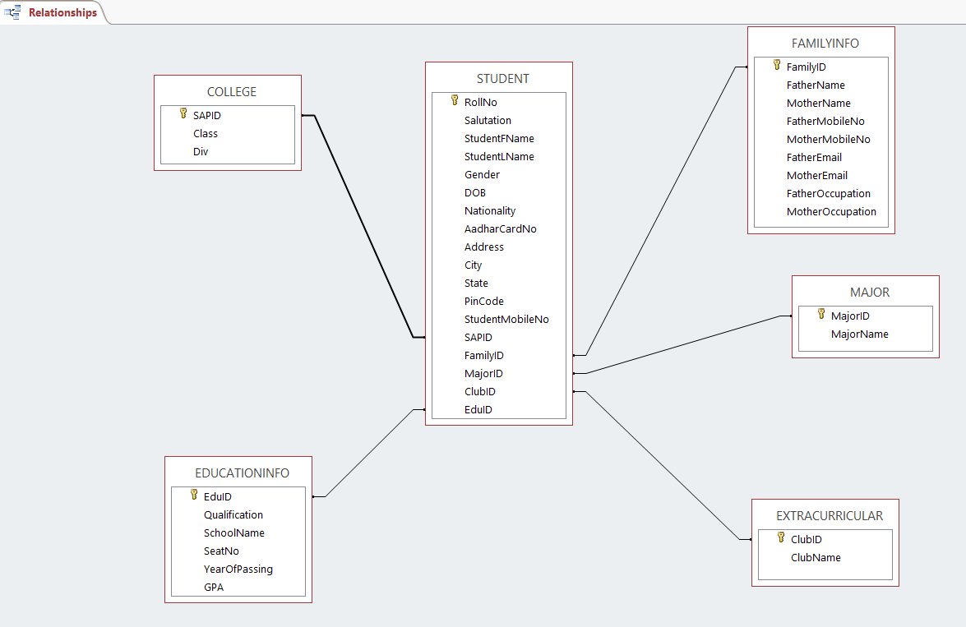

**CREATING A PHYSICAL ERD**

**STUDENT**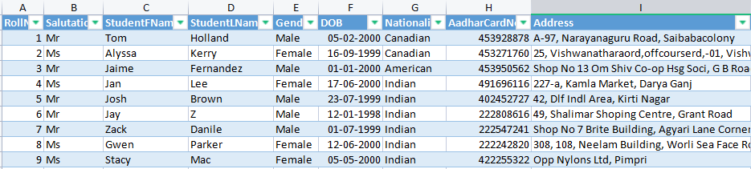

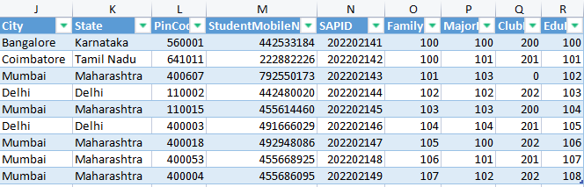

**EDUCATIONALINFO**

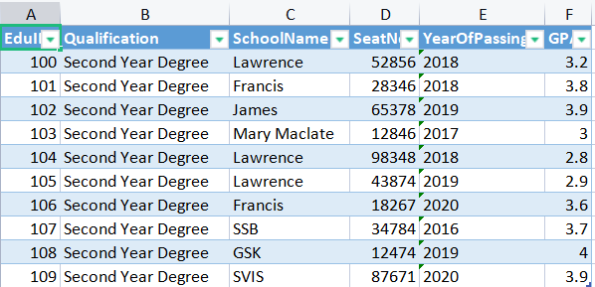

**FAMILYINFO**

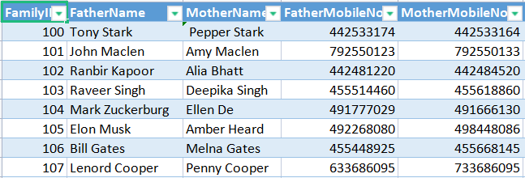

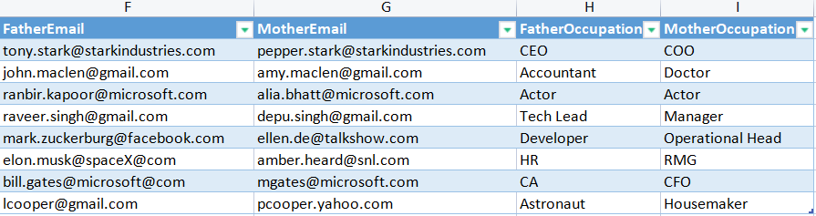

**MAJORS**

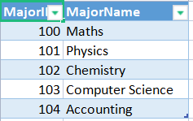

**EXTRACURRICULAR**

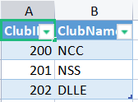

**COLLEGE**

